

Name: Ahmed Nazir
ID: 16046
Class: BS Data science
Subject: Database
Teacher Name: Hussnain Shakeel Siddique
Semester: 3rd
Project Title: National Library Management System

Objective Overview:
This project is about creating a basic Library Management System that helps users keep track of books, members, borrowing activity, fines, and the staff working in the library. The purpose of the system is to organize all the information so that daily library tasks can be done smoothly without confusion or missing records. It makes it easier to store, update, and access information, which helps solve the problem of managing library data manually.
This project includes tables for books, authors, publishers, members, staff, branches, borrowing records, and fines. Together, these tables manage all the important data related to the library in an organized way.

Project Objectives
- To Store all library information clearly create tables that hold details about books, members, authors, staff, and branches in an organized way.
- Track which books are borrowed, record who borrowed a book, when they borrowed it, and when it is due back.
- To keep a record of fines add a simple system to note fines for late returns, including the amount and payment status.
- To make searching and updating easier Use a database structure that allows quickly updates and prevents mistakes, like duplicate entries.

Normalization:
Normalization is a process used in databases to organize data so there are no duplicates, no unnecessary data, and everything is stored in the right place.

First Normal Form (1NF)
A table is in 1NF when:
- Every column has only one value (no multiple values in a single cell).
- There are no repeating groups.
- Every row can be uniquely identified.
Example from this database:
In the library system, each table stores only one value in each column. For example, the author table stores one author per row, and the book table stores one book per row. No column contains multiple values such as several authors in the same cell. This shows that the database follows 1NF.

Second Normal Form (2NF)
2NF means the table should already be in 1NF, and all non-key information must depend on the whole primary key (this mostly applies when a table has a combined key).
How my database uses 2NF:
The borrow_record table has a single primary key, and every column (borrow date, due date, return date) depends on that borrow ID.
The book table also stores information that depends only on the book ID.
This shows the database follows 2NF.

Third Normal Form (3NF)
3NF means the table should already be in 2NF, and no column should depend on another non-key column. In simple terms, every column should depend only on the primary key.
How my database uses 3NF:
The member table stores only member information. Details about membership fees and rules are kept in the membership_type table, not inside the member table. This prevents one non-key value from depending on another, and it removes repeated information.
This shows the database also follows 3NF.
Conclusion:
The Library Management System database is organized and cleaned using normalization steps up to Third Normal Form (3NF). As a result, the data is simpler, has no unnecessary repetition, and is stored in the correct tables.

Data Flow Diagram Level 0:
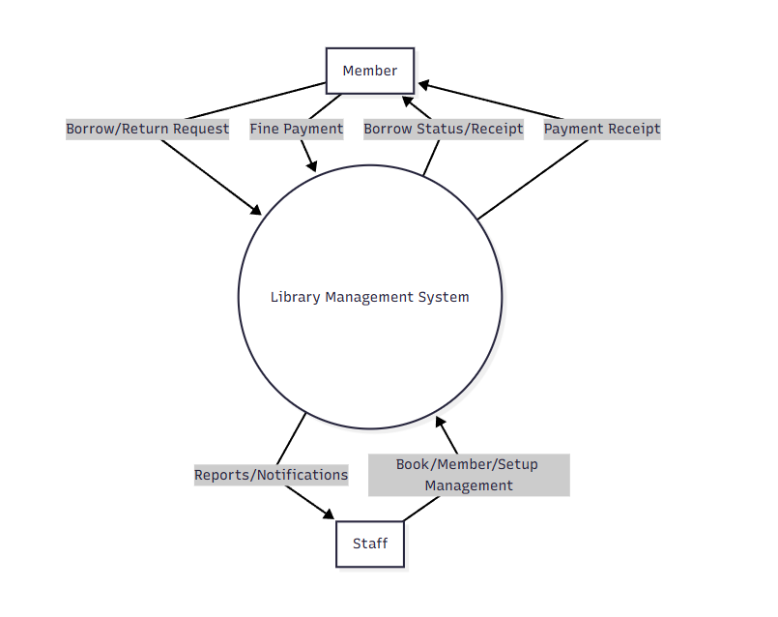

Data Flow Diagram Level 1: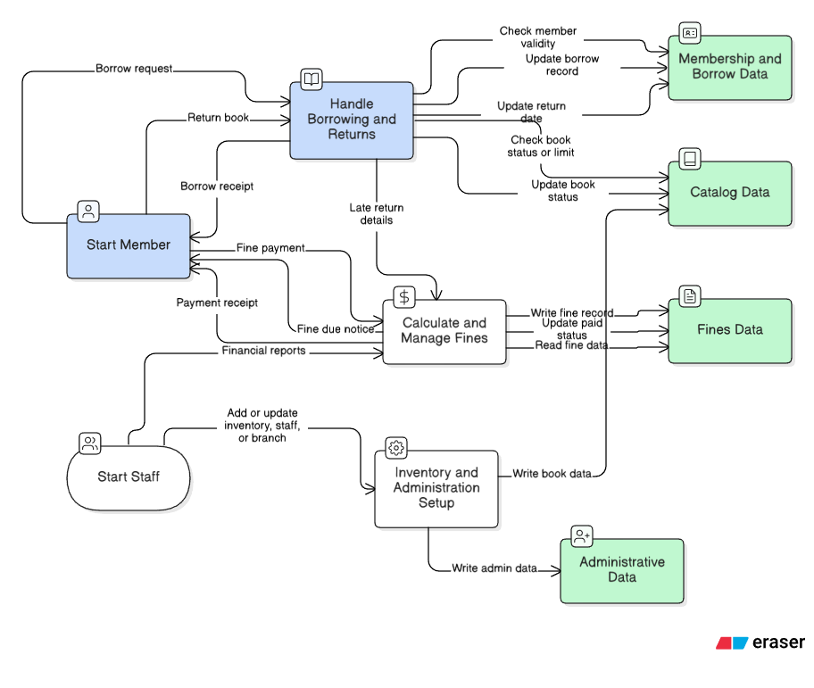Flow Diagram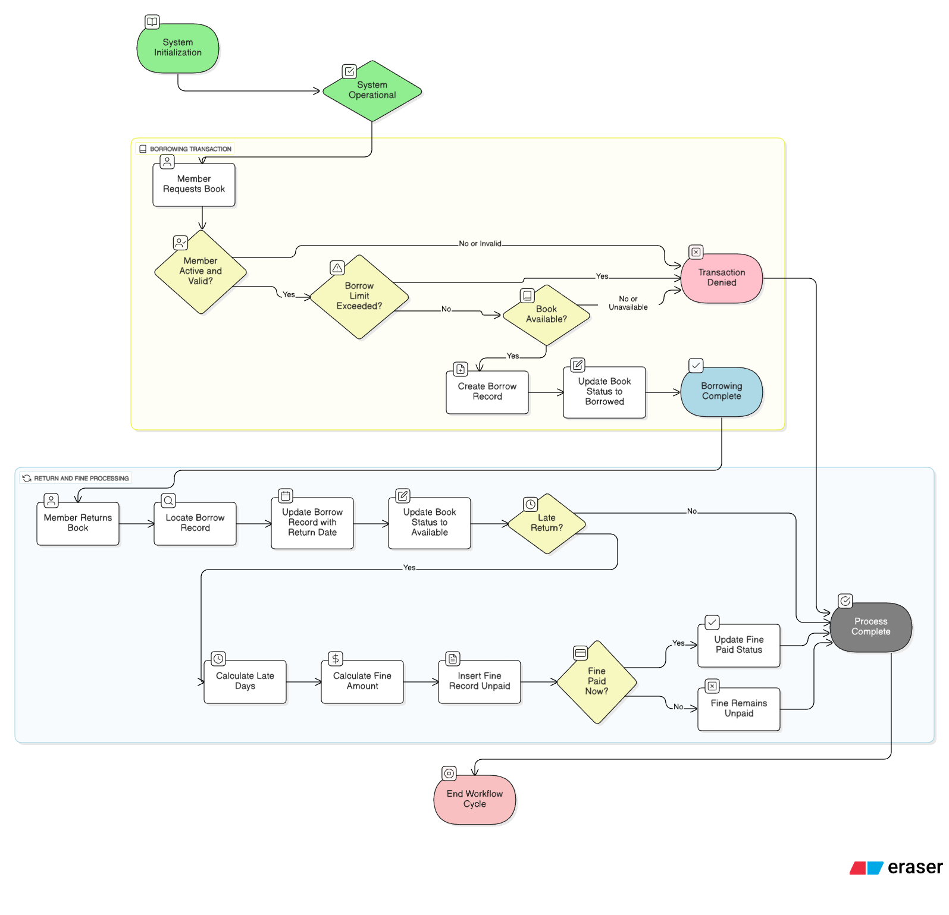
Entity Relationship diagram:
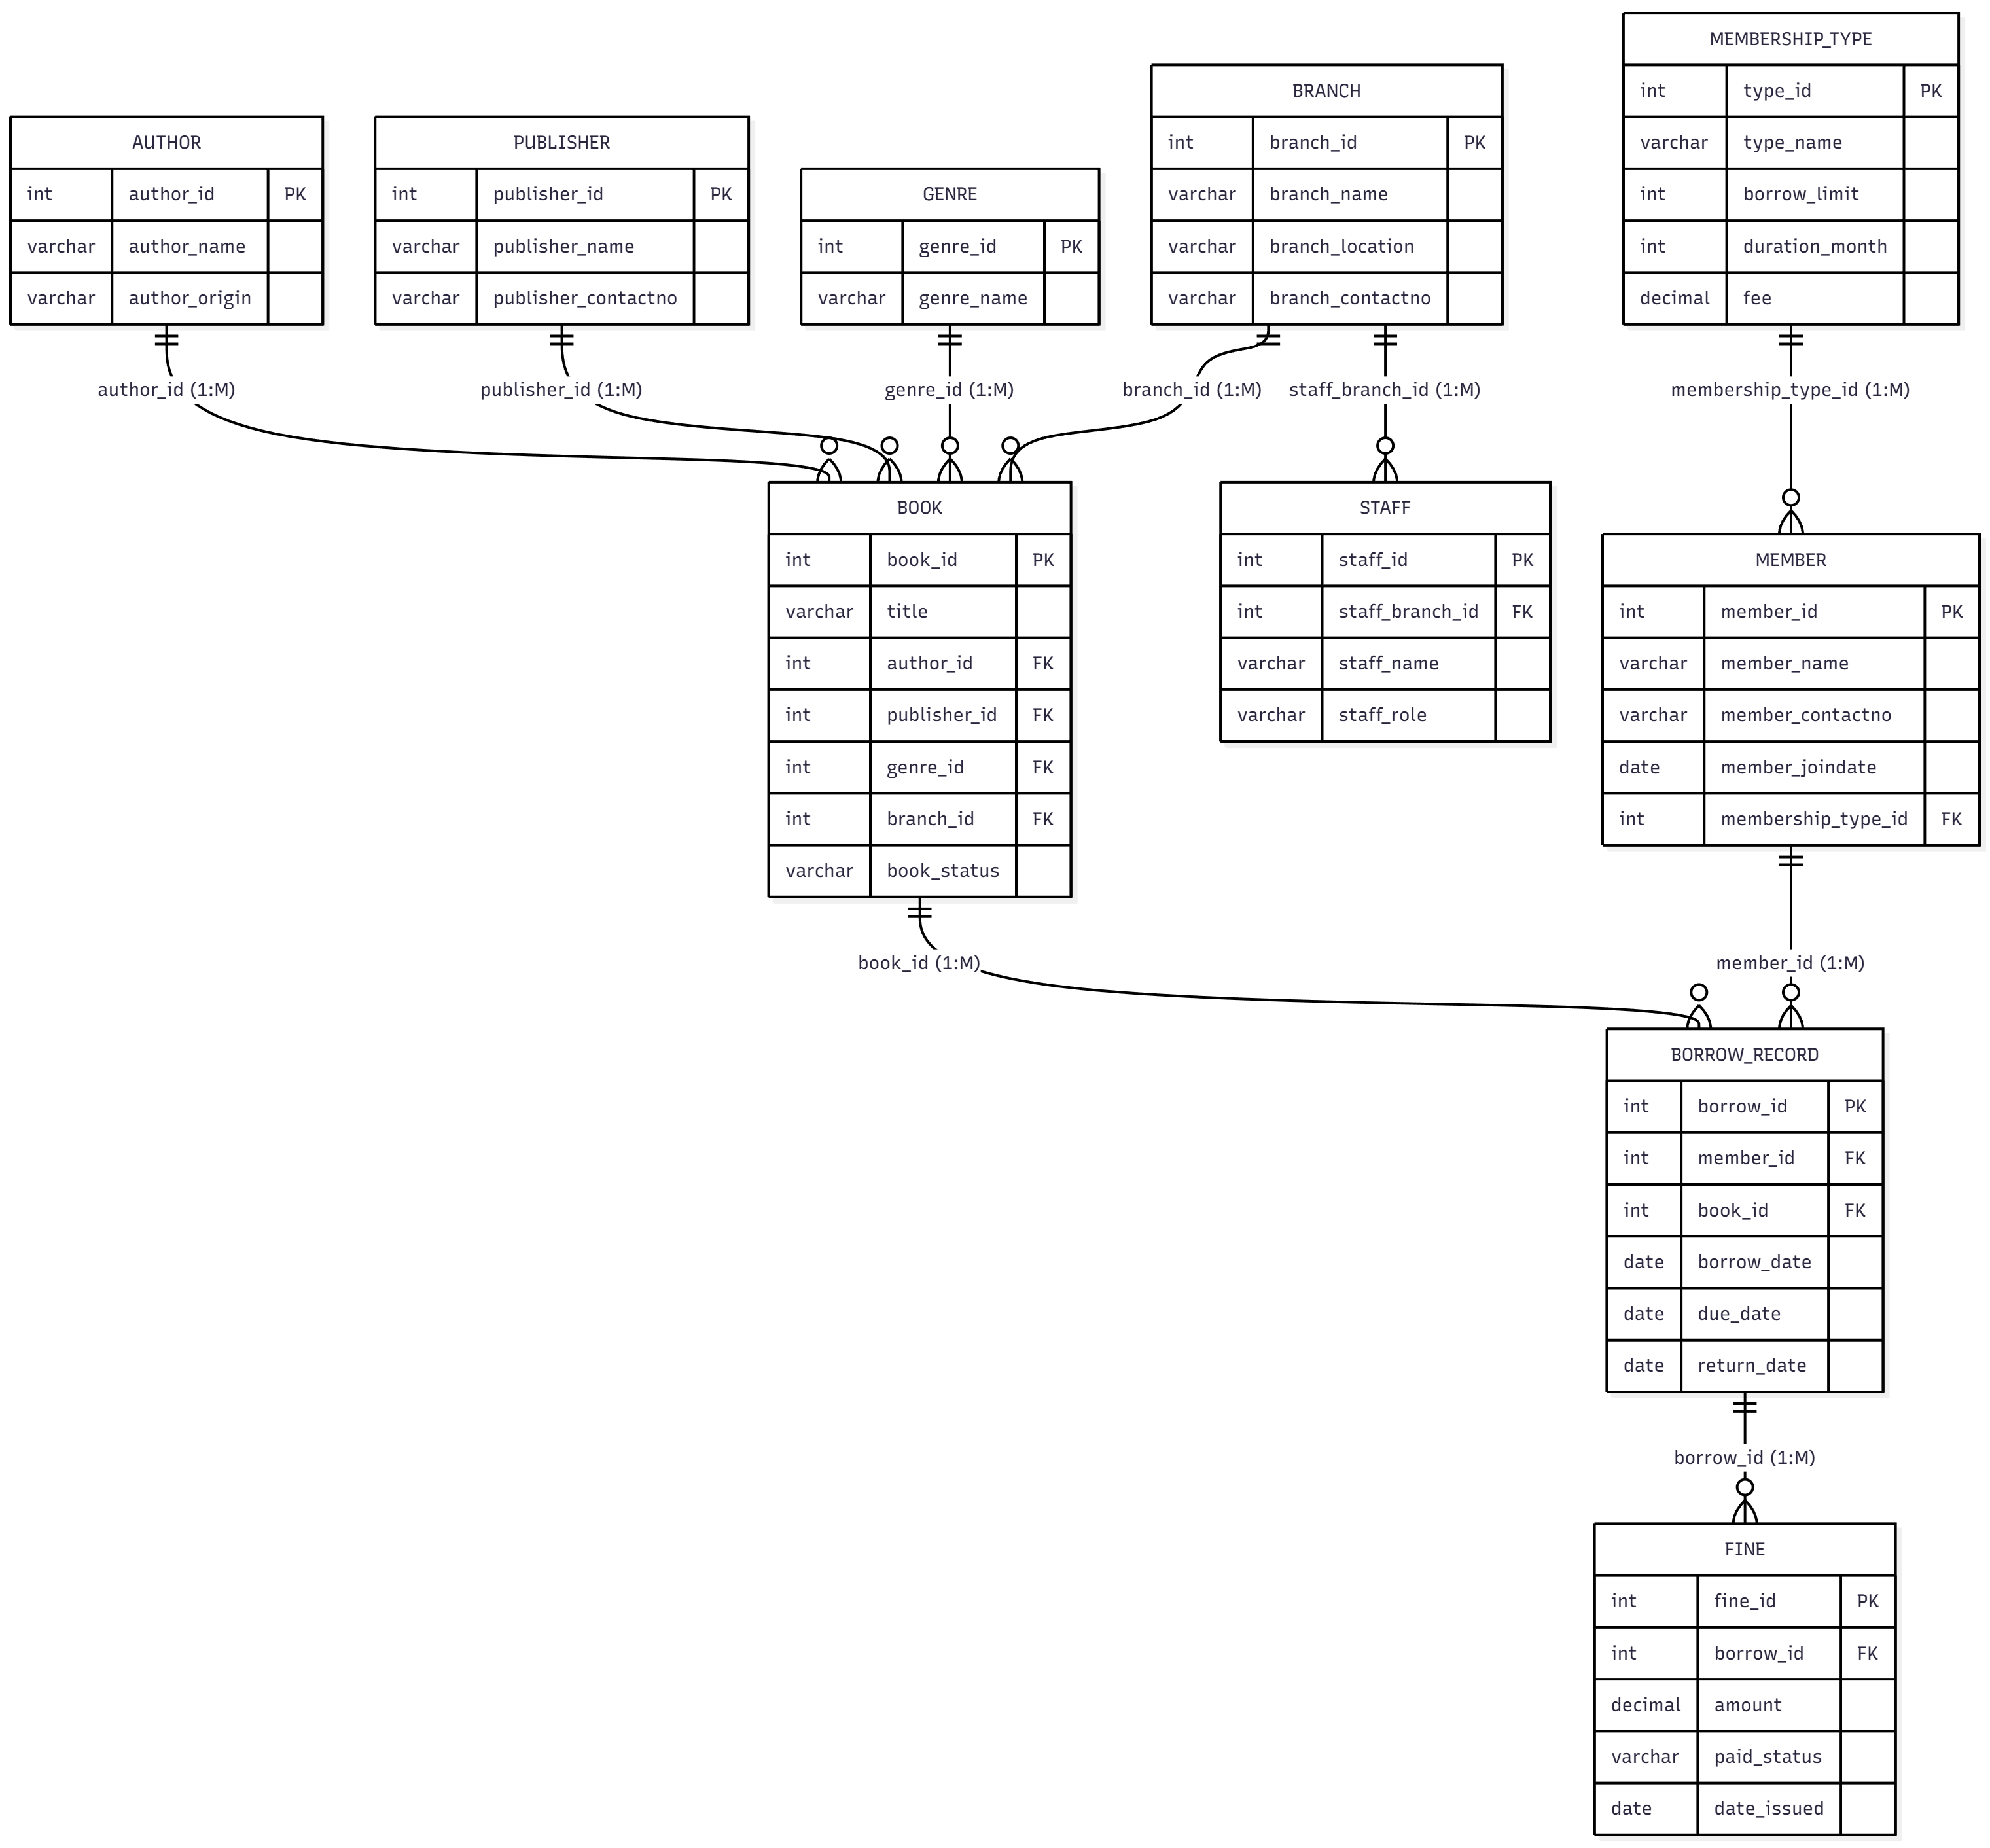

Database
Creating database:

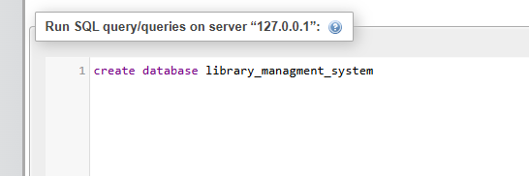
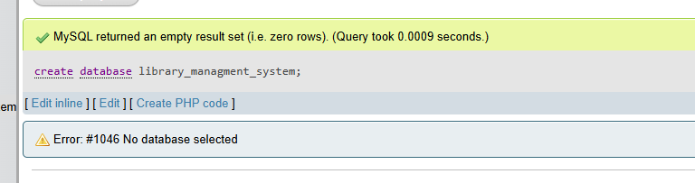

Author Tables:
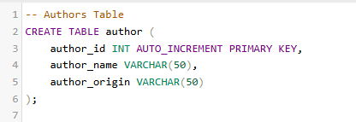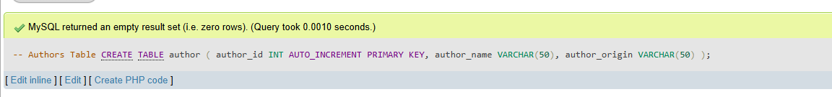
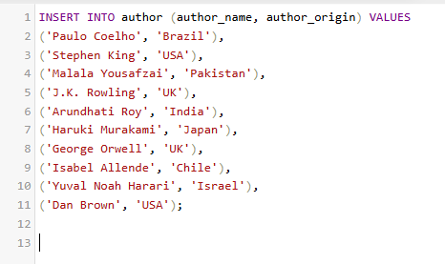

Publisher table:
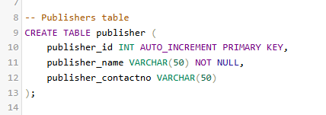
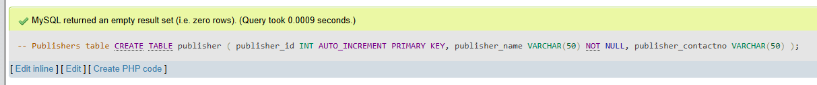
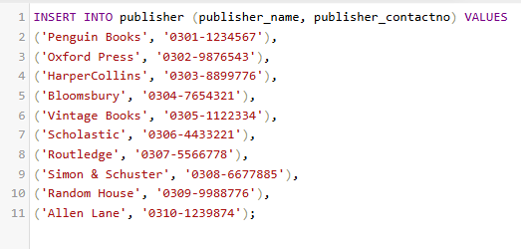

Genre Table:

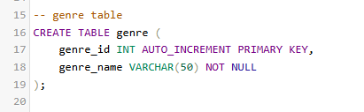
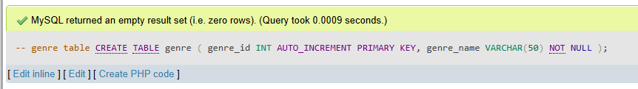
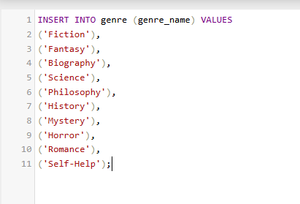
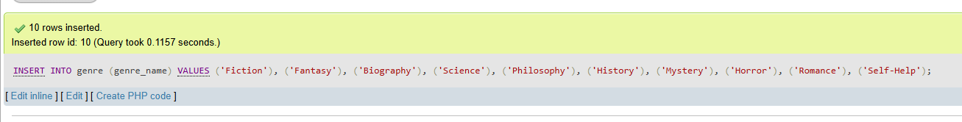

Book Table:
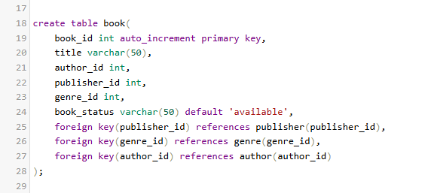
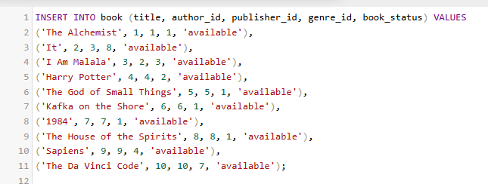
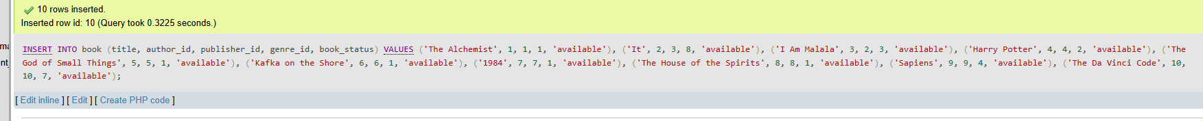

Membership Type table:

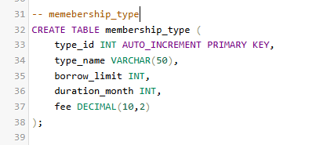
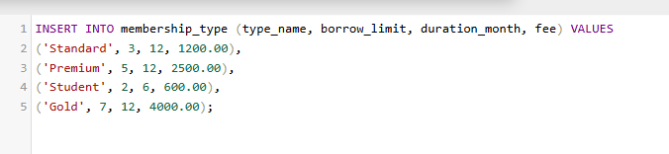

Member Table:

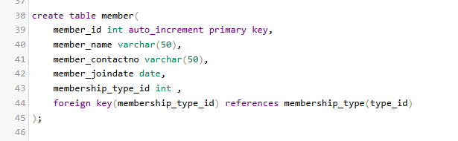
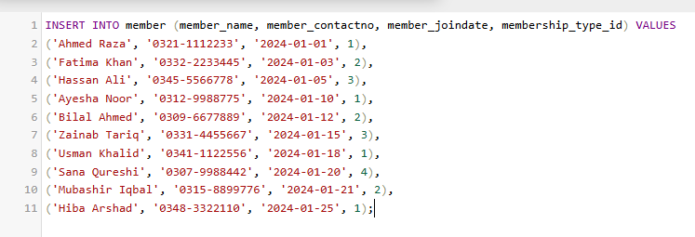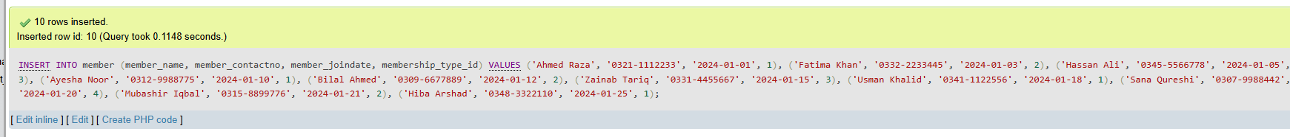

Borrow Record Table:
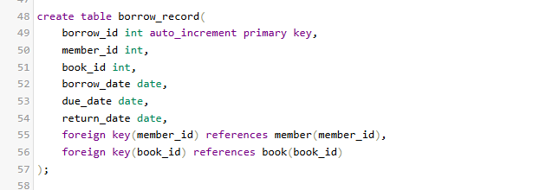

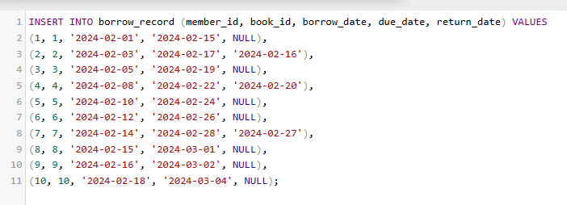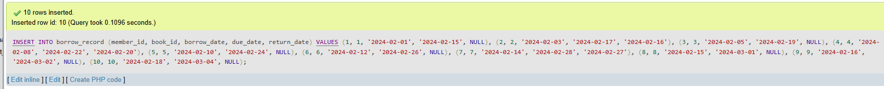

Fine Table:

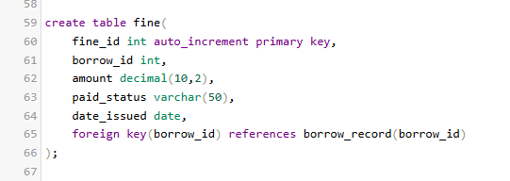
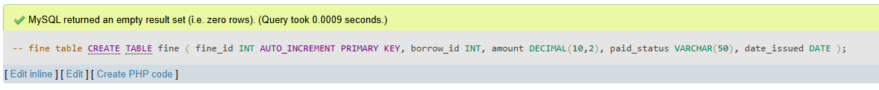
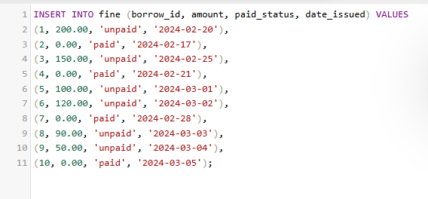

Branch Table:

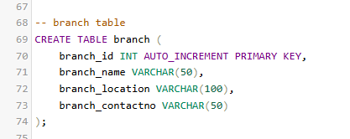
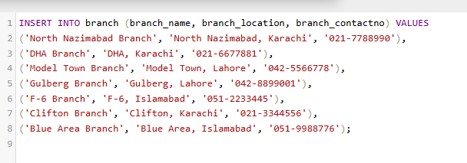

Staff Table:

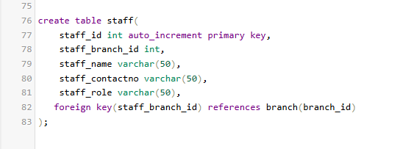
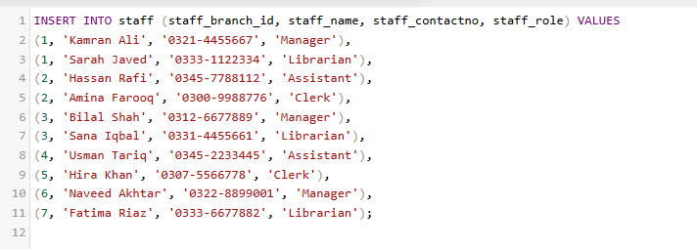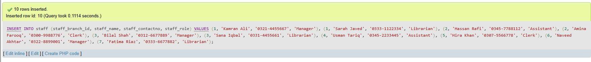

Joins:
Inner join:
To show all the books with their author name and genre
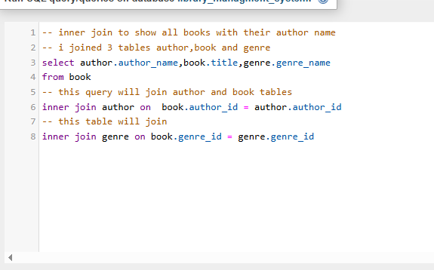
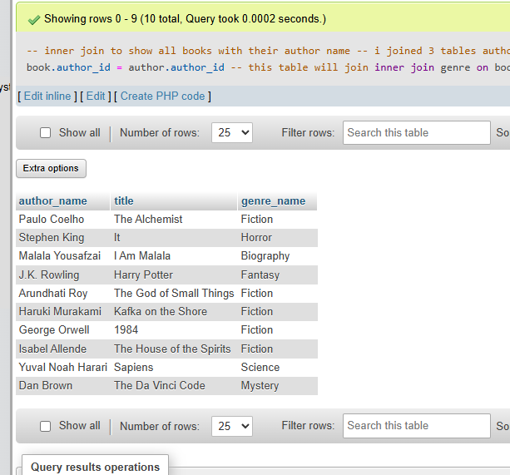

Right join:
To show all branches and the staff working there

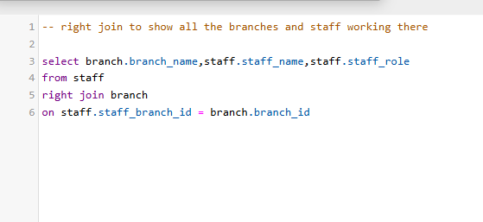
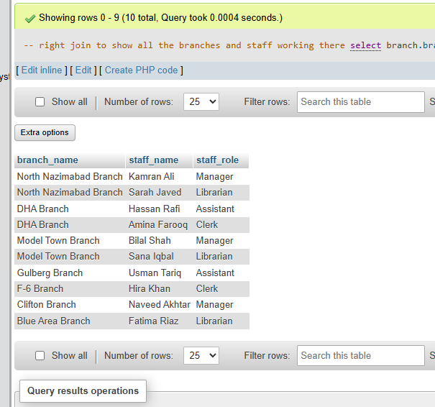
Left join:
To show all members and their borrow records
